Wren Farm VA Xtraordinary
DOB: 3/19/15
Information from Shere Country
06/19/16: Tested for CAE - results negative
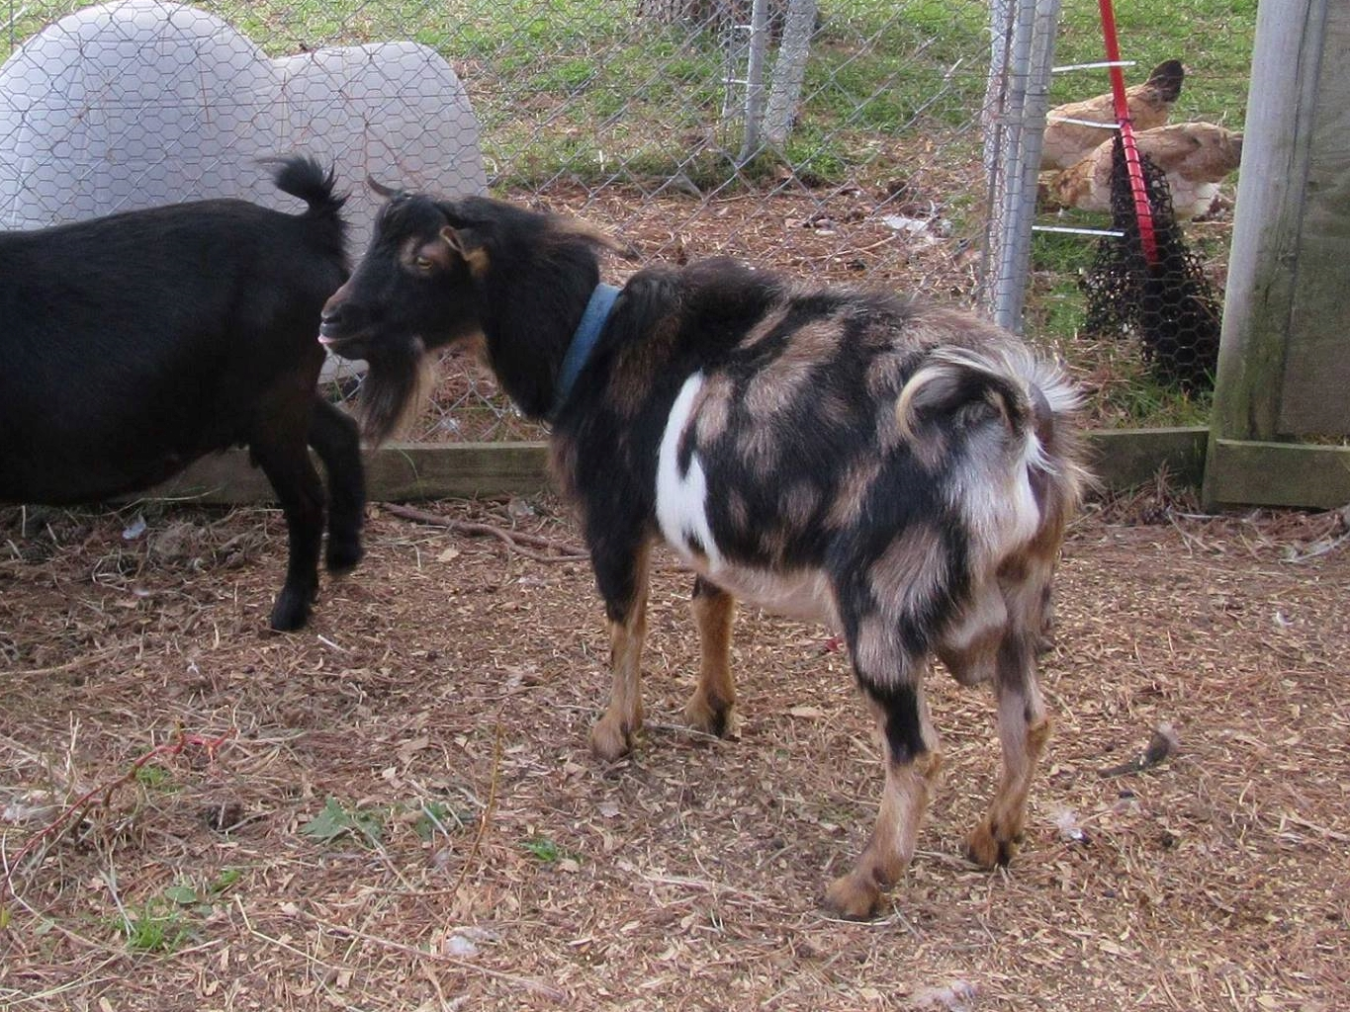
Xtraordinary is shown above on 10/10/16. He is shown below at just a few hours old. He is the kid on the left. His baby photo and pictures of his relatives are courtesy of Wren Hill Farm.

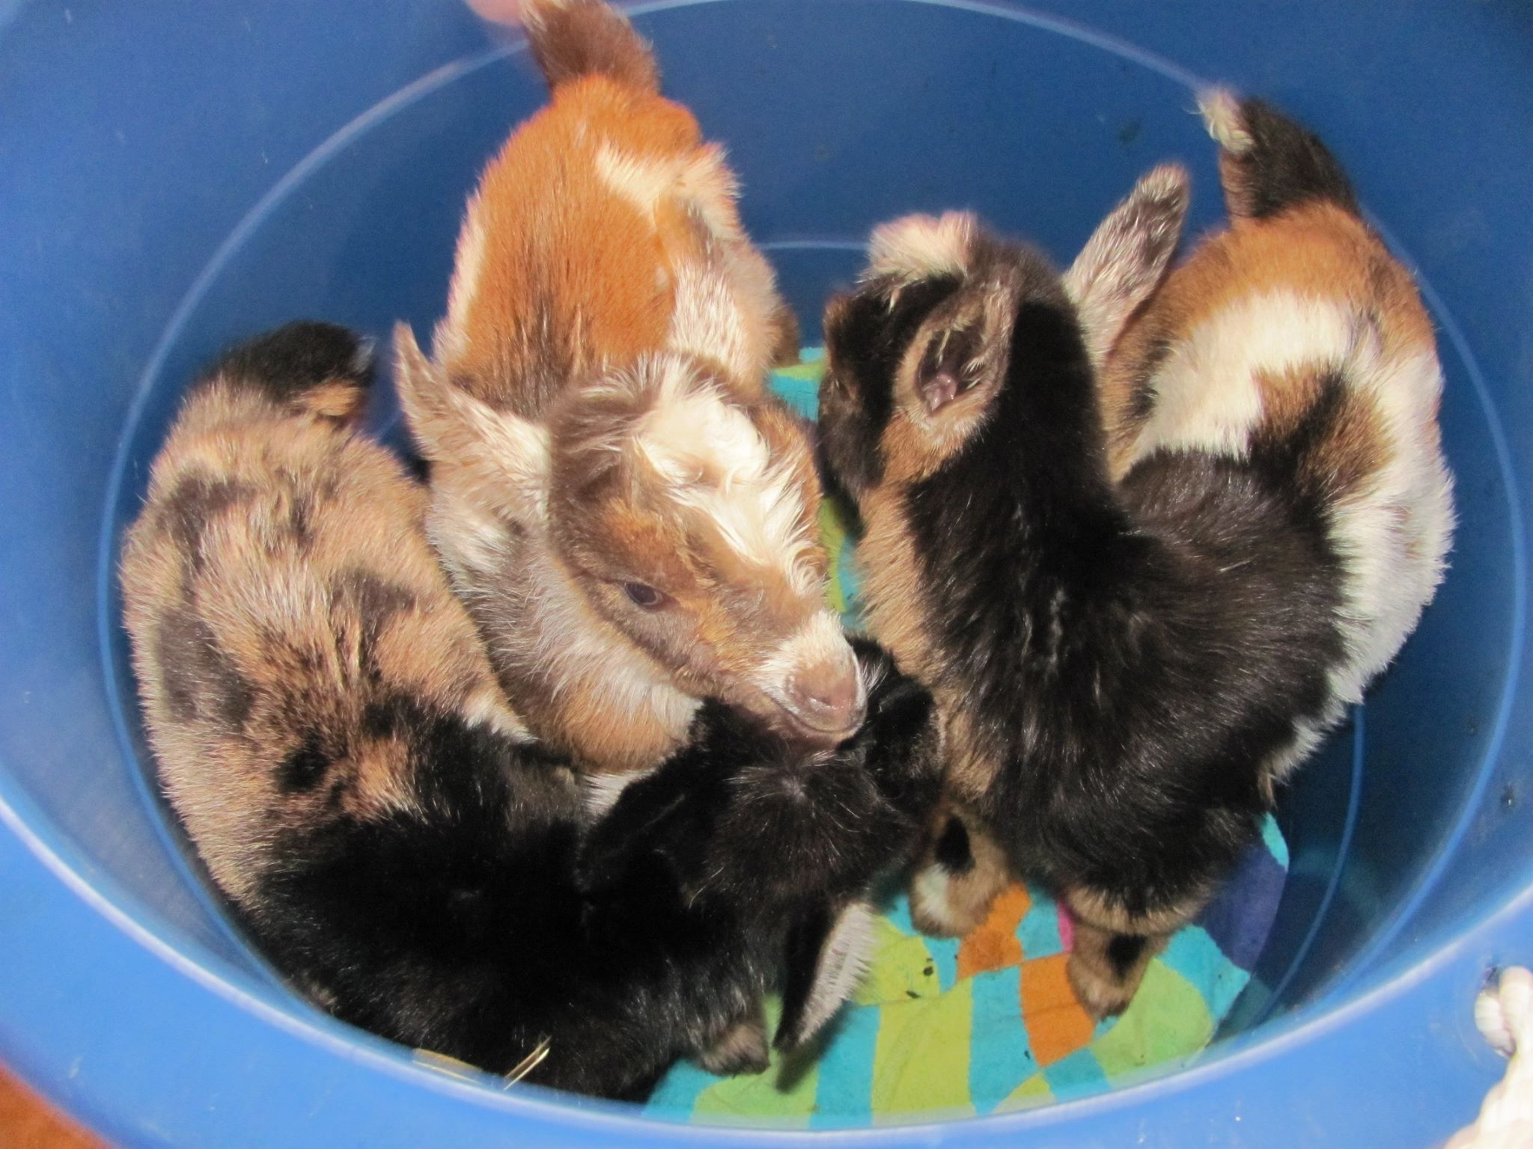
Xtraordinary is pictured at 4 months and freshly clipped in the picture below.
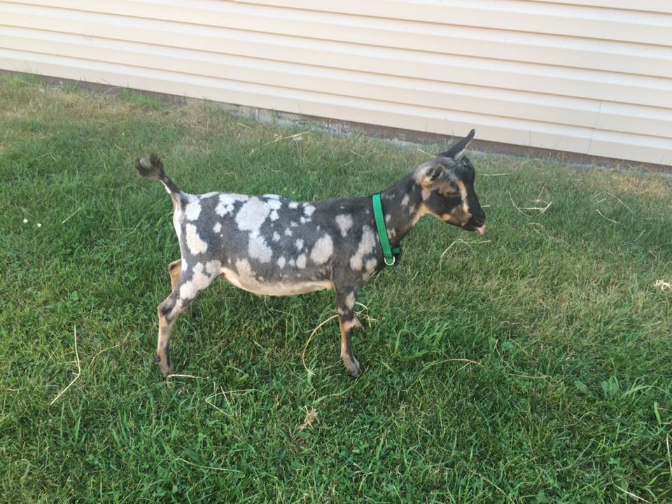
His dam is 2*M GCH MI Sugarcreek WM Xtrafly 'VG89' (+EVE). Xtrafly was the 5th place doe in the 5 - 6 year-old class at the 2013 ADGA National show. She is currently the high producer at Wren Hill Farm. The udder photo were taken at the 2012 Olmstead County Fair. Xtrafly was Linear Appraised in 2013 and scored +EVE FS89.
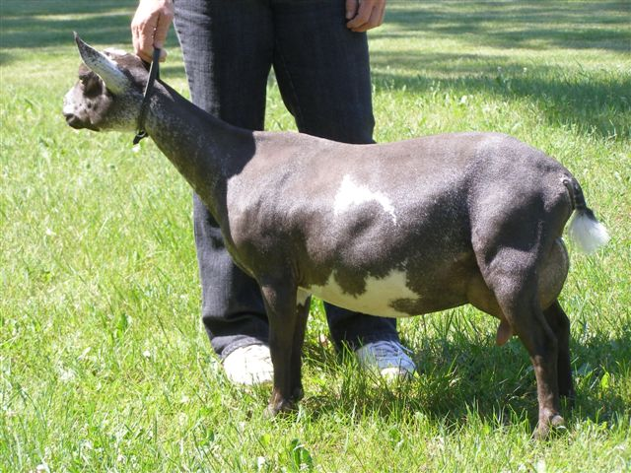
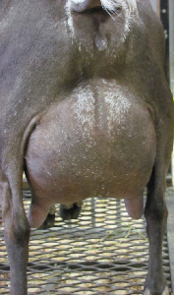
Pictured below is the buckling's sire, AGS Fall Creek WR Valentino *S.
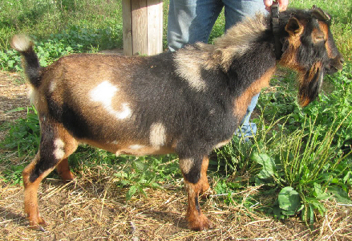
Here's what Allan has to say about him:
"Valentino" is very dairy in appearance with excellent feet and legs, great width throughout, open ribbing, sharp at the shoulder and has thin pliable skin. He brings wonderful proven dairy genetics and production from both sides of his pedigree.
His dam, MCH Fall Creek TAL Valentine *D, is a powerhouse milker with a buttery soft udder. Her medial is strong and very well defined and her fore udder extension is wonderful, as is the height and width of her rear udder. In a one-day milk test, Valentine earned her milk star at two weeks fresh with a 6.8% butterfat! She has proven herself in the show ring with several Grand Champion, Best of Breed, and Best Udder wins as well.

Color/Pattern Genetics:
He is a brown and black buckskin with moonspots.

See his extended pedigree here: Xtraordinary's Pedigree

Sire: AGS Fall Creek WR Valentino *S
SS: Lost Valley SD Waverunner *S
SD: MCH Fall Creek Valentine *D

Dam: 2*M GCH MI Sugarcreek WM Xtrafly 'VG89'
DS: AGS MI Sugarcreek Wager On Me *S
DD: 1*M AGS Sugar Creek KN Shutterfly *D

WREN FARM VA XTRAORDINARY
Registration - ADGA: D1748144 AGS:
Nigerian Dwarf Buck
Born - 3/19/15
Owned by - Julie Shere
Last Updated: 11/1/16

Parents | Grand-Parents | G Grand-Parents | GG Grand-Parents
FALL CREEK WR VALENTINO *S | AGS LOST VALLEY SD WAVERUNNER *S | LOST VALLEY DAX SEA DOO *S | AGS LOST VALLEY KW DAXUS *S
 |  |  | 2*M ARMCH LOST VALLEY TREASURE 3*D AR1268
 |  | 2*M ARMCH/GCH LOST VALLEY LACEY 2*D (2009 AGS National Best Udder) | AGS LOST PINES PRINCE + *S
 |  |  | 1*M AGS GOODWOOD SISLEY *D 'VG'
 | MCH FALL CREEK TAL VALENTINE *D | MCH BRUSH CREEK SF TALISMAN *B | AGS CAESAR'S VILLA FD SUGAR FOOT *S
 |  |  | AGS CAESAR'S VILLA CBS ZELDA
 |  | AGS FALL CREEK RC SIREN | LOST VALLEY KW RAISING CAIN *S
 |  |  | BRUSH CREEK LILLI
2*M GCH MI SUGARCREEK WM XTRAFLY 'VG89' | MI SUGARCREEK WAGER ON ME *S | DILL'S OH MIGHTY OAK *S | DILL'S GO OLD HICKORY *S
 |  |  | PROMISEDLAND LD MIMNET 3*D
 |  | 1*M MCH/GCH TWIN CREEKS TALK ABOUT ME 5*D 'E' | ++B MCH GOODWOOD WIESBADEN + * S
 |  |  | ARMCH TWIN CREEKS BH MARIRI'S ZINNIA 4*D
 | 1*M AGS SUGAR CREEK KN SHUTTERFLY *D | SUGAR CREEK NT FLOWER'S KENNY *S | + *+B SUGAR CREEK MT SALLY'S NATE + * S
 |  |  | AGS TWIN CREEKS BH MAE FLOWER
 |  | AGS SUGAR CREEK MT PUTTERFLY | ++B MCH GAY-MOR'S DOMINO'S MANTIS +S
 |  |  | 1*M ARMCH GAY-MOR'S RA MAYFLY 4*D

