Sugar Moon Zenaida
Information from Shere Country

DOB: 2/11/11
03/04/18: Tested for CAE & Johnes - results negative
02/19/17: Tested for CAE - results negative
06/13/16: Tested for CAE - results negative
1/25/15: Tested for CAE & Johnes - both results negative
11/16/13: Tested for CAE - results negative

2014 LA: Unfortunately, Zenaida apparently absorbed her tattoos and couldn't be appraised.

Zenaida is shown below on 10/10/16 with Wren Farm VA Xtraordinary.
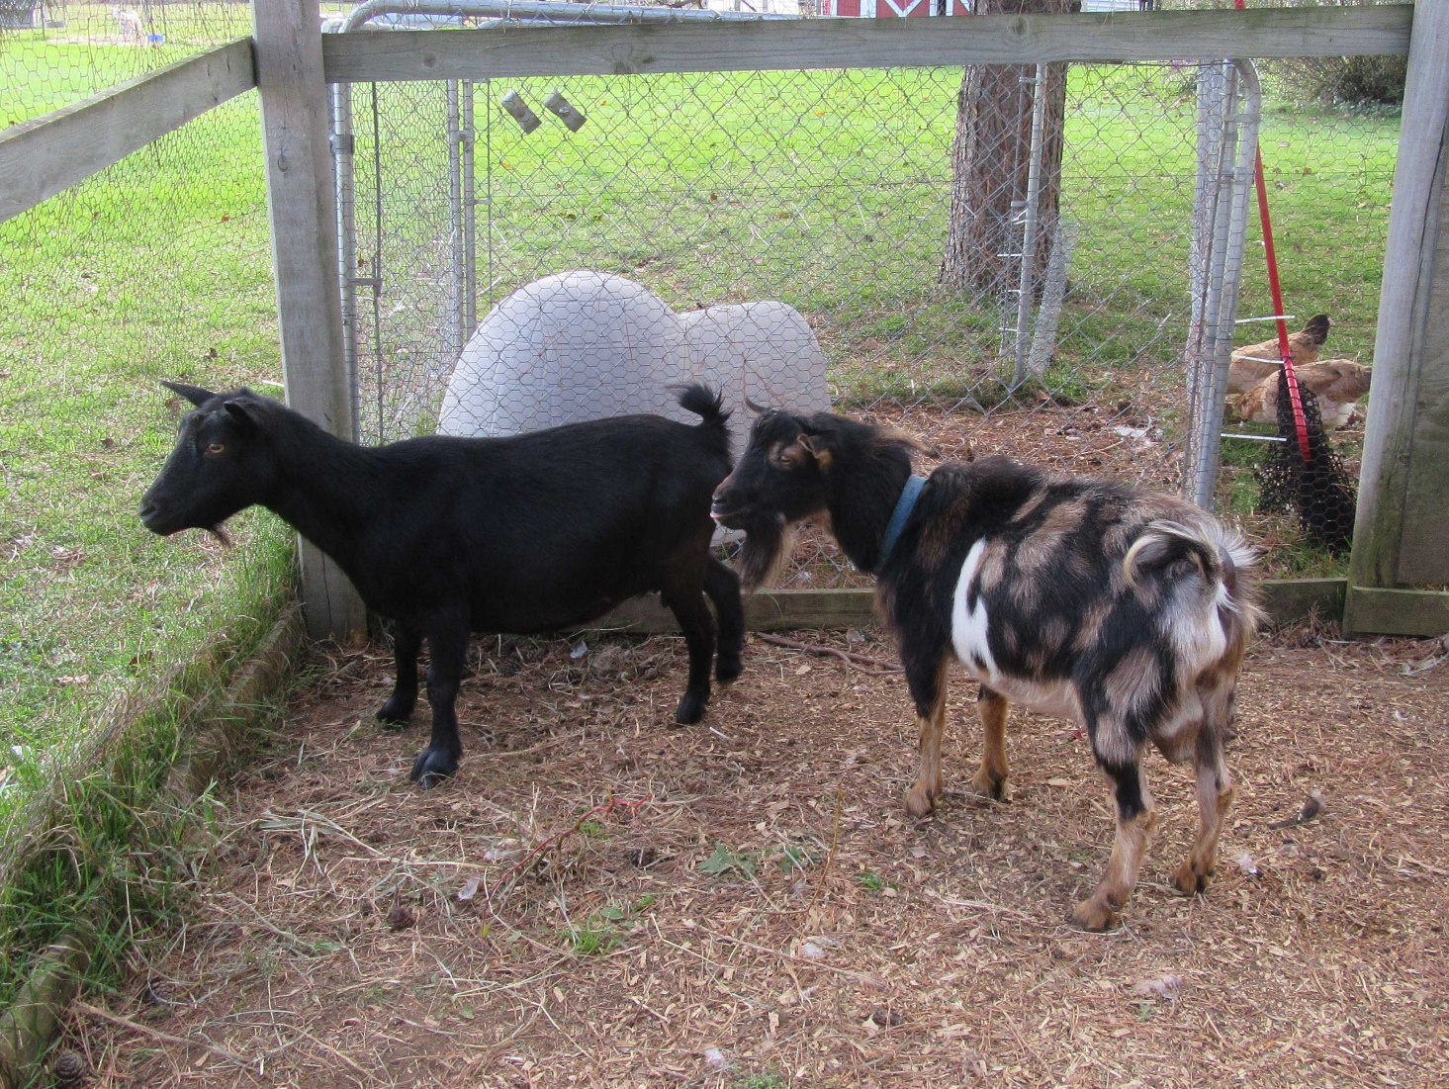
Zenaida is shown below as a dry yearling.
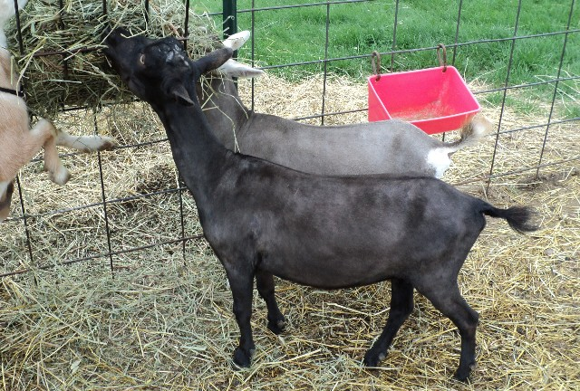

Update 11/16/17: Many thanks to Curtis Gerry (Jr) at Amethyst Acres for providing me with the following information and photos of Zenaida's full younger sister, SG Sugar Moon RB Gianna!
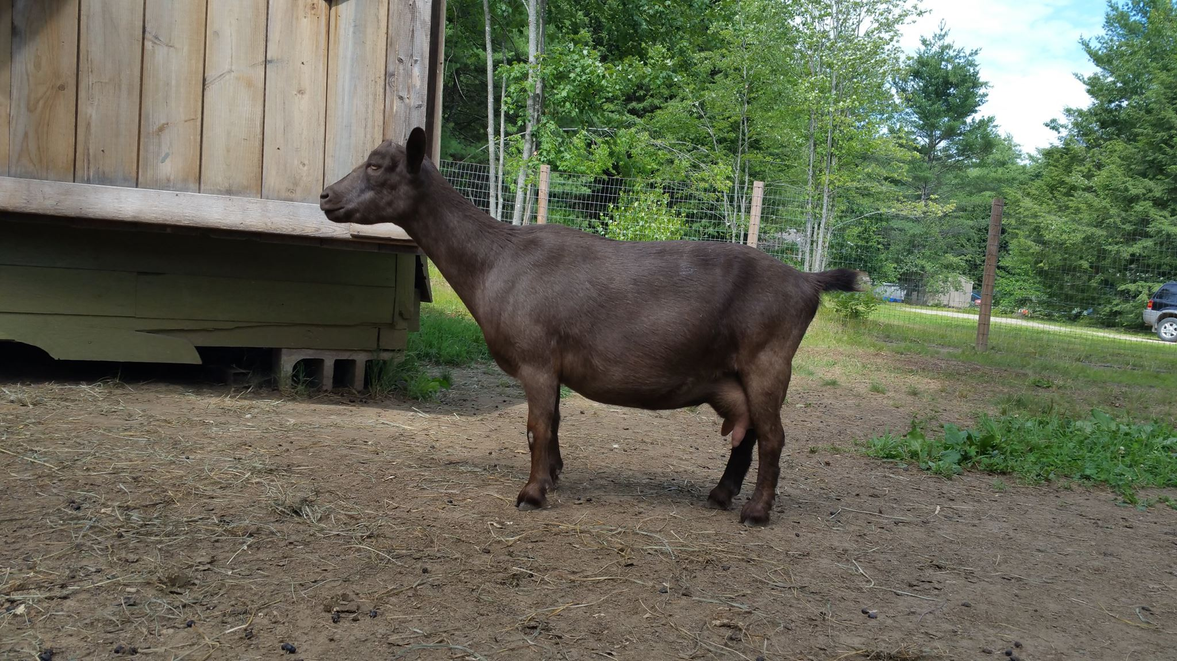
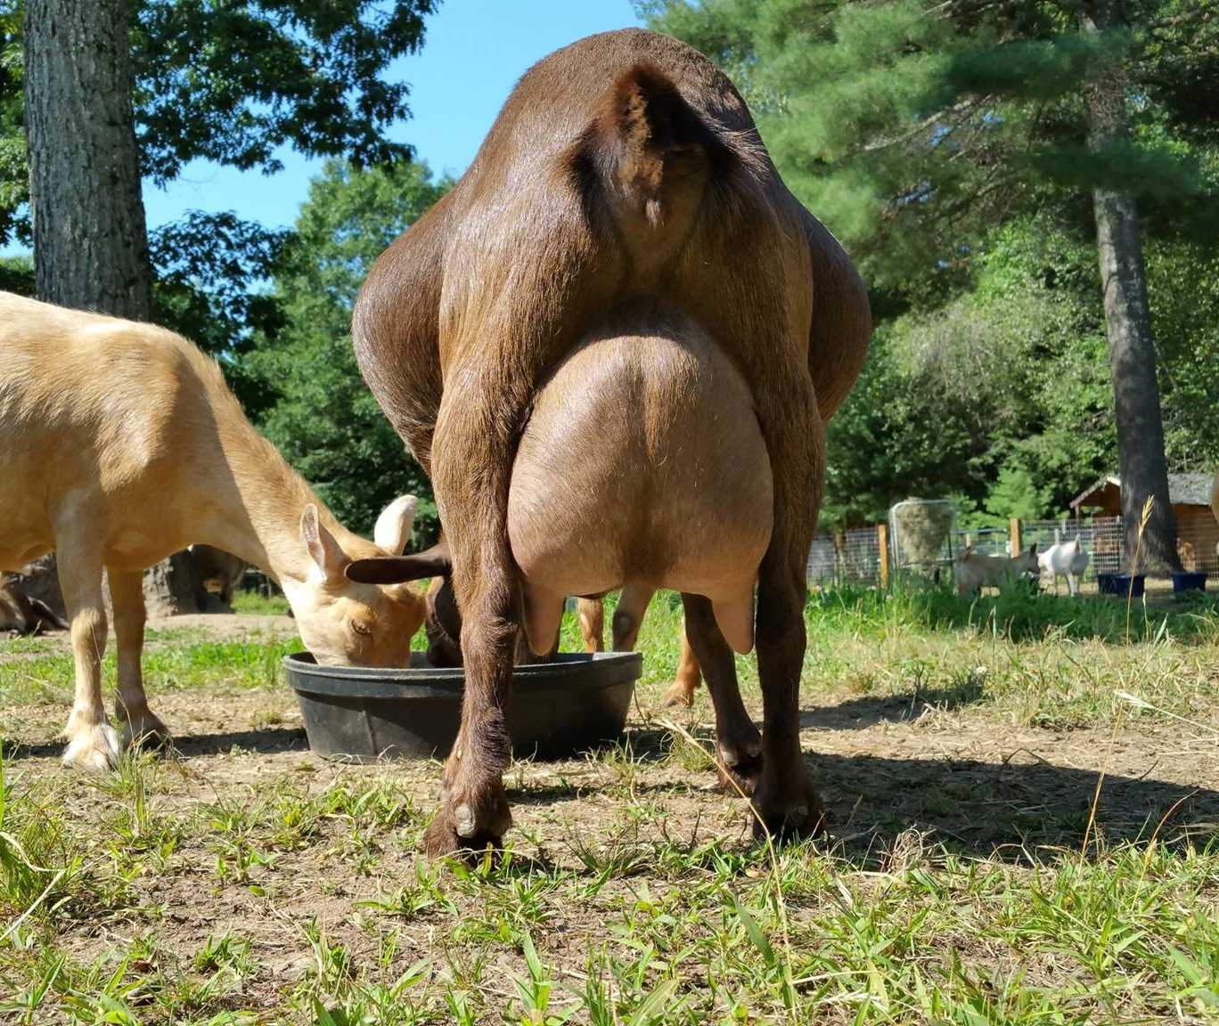
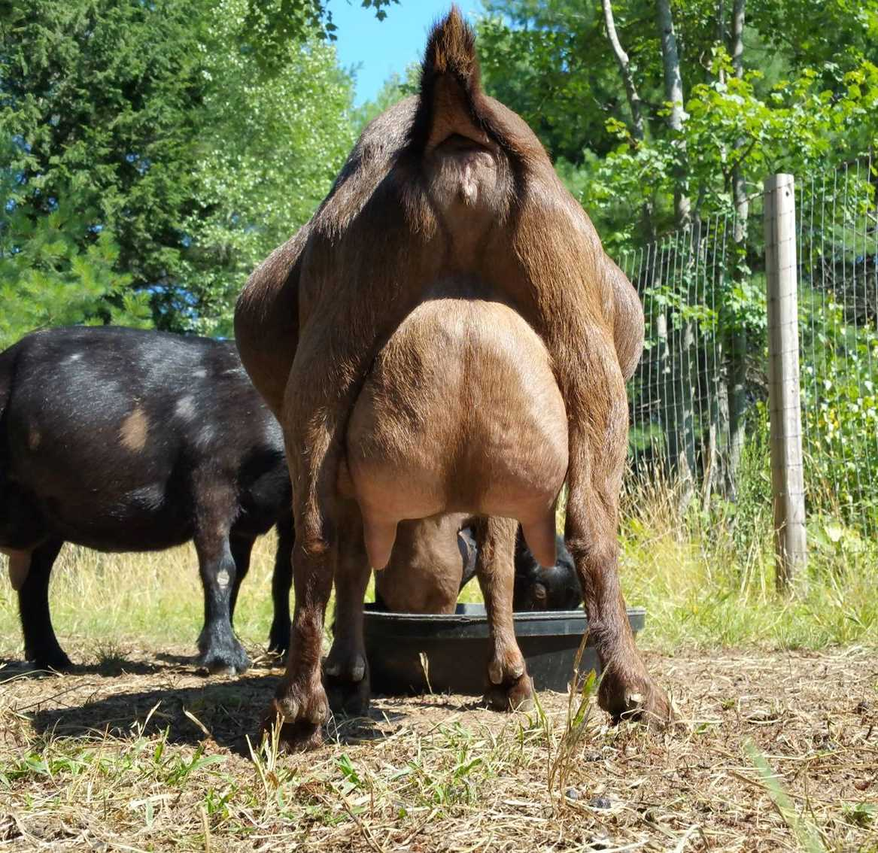
SG Sugar Moon RB Gianna was Linear Appraised VVEE FS89 in 2015 as a 1st freshener. That is the highest score a first freshener can receive! She was also on the 2015 - 2017 ADGA Elite Doe List (99th Percentile). Here's what her owner has to say about her: Gianna has a beautiful udder with extremely velvety texture, high and well attached, effortless milker, lots of capacity and great production! Her sire SG NC PromisedLand Ram-Beau is #3 on the 2017 USDA's Elite Buck List (97th Percentile) with (PTA) Milk +91 & has one of the highest REL's in the breed! Consistently passing on great production & type!
'
Update 8/24/15: Both Zenaida's sire and her littermate brother made ADGA's August 2015 Elite Buck list!
Update 11/21/14: Just checked out the latest ADGA Top Ten Breed Leaders (2013) and Zenaida's dam, SG NC PromisedLand PAL Paloma 1*M earned the #3 spot in milk production with 1290 lbs in 305 days! She was # 2 in both Butterfat and Protein Production.
Zenaida is a solid black doe who is the result of another excellent production breeding. Her dam earned her SG (Superior Genetics) designation in 2011 and is now SG NC PromisedLand PAL Paloma *D *M 'E90', and her littermate brother, + *B SG Sugar Moon Rocky Dolby, is a herd sire at Pholia Farm Creamery and Dairy, and according to them, his first freshening daughters are some of their best, earning their SG designation at a very young age! They consider Rocky Dolby to so far be one of their best bucks ever. Zenaida has been very stingy with doe kids, producing only bucks in her first two freshenings, but hopefully she will bless me with at least one in 2015! Photo of Rocky Dolby below is courtesy of Pholia Farm.
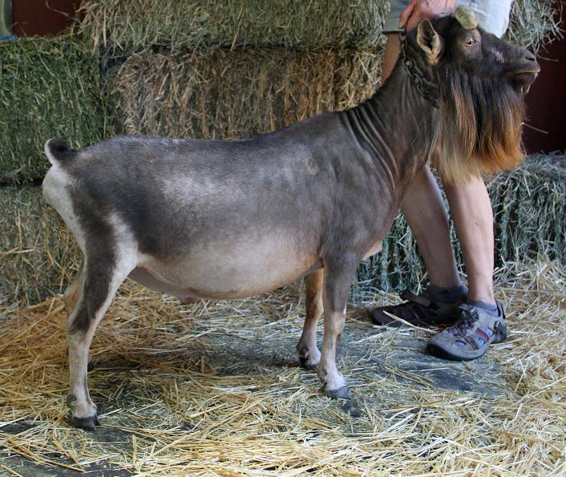
Zenaida's first fresh udder is shown below. She has amazing udder texture, and great teat size and medial, something that is quite often lacking in the breed.
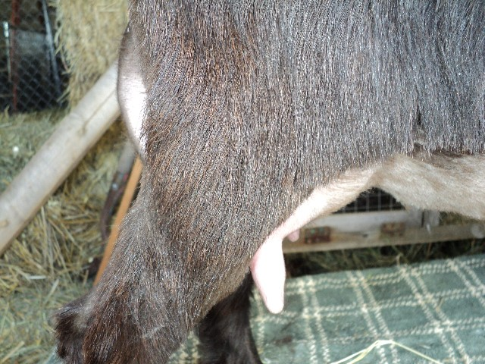
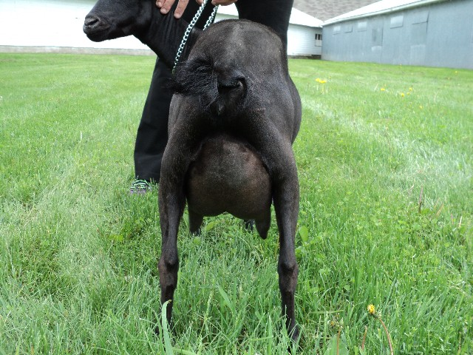
The photo of Zenaida's dam's udder shown below is courtesy of Willow Moon Farm.
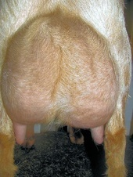
Zenaida's sire, +*B SG NC PromisedLand Ram Beau *S 'E91', is pictured below courtesy of Keith and Marie Harrell of PromisedLand Farm.
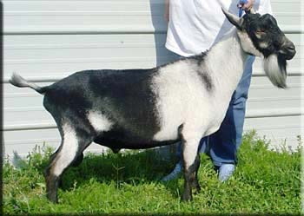

Show Wins

Color/Pattern Genetics:
Zenaida is solid black.

Kidding History:
03/09/13: Twin bucks sired by *B Dill's XM Lonestar *S 'E90'
03/21/14: Twin bucks sired by *B DesertNanny BR Shenandoah *S
06/16/15: Buck/doe twins sired by Zanzabeez ZSR Snap To It
04/11/16: Single buck sired by Dynamo Falcon Ziggzag 'E90'
03/12/17: Triplets - 2 bucks/1 doe sired by Wren Farm VA Xtraordinary (see Shere Country X Socorro Dove)
03/18/18: Triplet bucks sired by Shere Country ST Albert

See her extended pedigree here: Zenaida's Pedigree

Sire: + *B SG NC PromisedLand Ram Beau *S 'E91'
SS: ++ B SG NC PromisedLand Beau + *S
SD: 1*M Caesar's Villa Lizzie 3 *D 'VG'

Dam: SG NC PromisedLand PAL Paloma *D *M 'E90'
DS: ++ *B SGCH Buttin' Heads Palimony +S 'E90'
DD: NC PromisedLand SS Thistle 'VG'

SUGAR MOON ZENAIDA
Registration - ADGA: D1554534 AGS:
Nigerian Dwarf Doe
Born - 02/11/11
Owned by - Julie Shere
Last Updated: 7/21/15

Parents | Grand-Parents | G Grand-Parents | GG Grand-Parents
+ *B SG NC PROMISEDLAND RAM-BEAU *S 'E91' | ++ * B SG NC PROMISEDLAND MG BEAU + *S 'VG' | ++ B SG ARMCH PROMISEDLAND S MEL GIBSON + *S 'VG' | MCH MAPLE TREE KNOLL SNICKERS 'E'
 |  |  | CAESAR'S VILLA CBS MINUET 2*D 'E'
 |  | PROMISEDLAND MY FAIR LADY 3*D | MCH MUNCHRANCH DENNIS THE MENACE *S 'E'
 |  |  | WOOLY DOG DOWN JUNE BUG 2*D
 | *M CAESAR'S VILLA DN LIZZIE 3*D | DOVER CLIFF DUNCAN | DOVER CLIFF SCOTT
 |  |  | DOVER CLIFF GOLDIE
 |  | CAESAR'S VILLA CBS LYNN MARIE 2*D | STONEWALL'S MIDNIGHT COWBOY ++ *S
 |  |  | GOODWOOD MINDY *D
SG NC PROMISEDLAND PAL PALOMA *D, *M | ++ *B SGCH BUTTIN'HEADS PALIMONY +S 'E90' | +B BUTTIN'HEADS PAJAMARS | BUTTIN'HEADS MENDLESON'S MARCH
 |  |  | CH BUTTIN'HEADS ZIPTHER
 |  | *M ARMCH/GCH BUTTIN'HEADS WEDDING SONG 3*D 'E91' | CREEK ROAD HUDSON +S
 |  |  | ARMCH BUTTIN'HEADS BRYEDAL VEIL 2*D
 | NC PROMISEDLAND SS THISTLE 'VG' | AGS PROMISEDLAND CP SEYMORE SPOTS + *S | +B ARMCH CAESAR'S VILLA CBS COWPOKE ++ *S 'E'
 |  |  | PROMISEDLAND CINDER ELLA 2*D 'E'
 |  | AGS PROMISEDLAND CAD THIS ONE  AGS National Champion Jr. Doe | WOODHAVEN FARMS COWBOY CADILAK
 |  |  | MCH GREEN GATE LIL' RED RIDING HOOD *D 'E'

